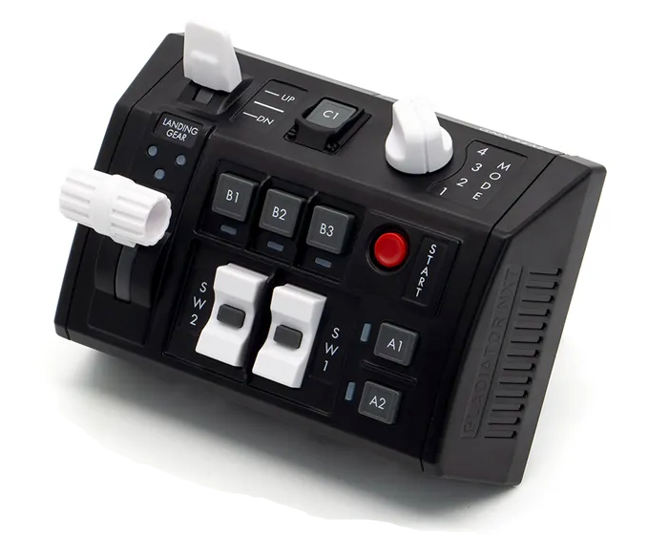  1xx - Controls | 2xx - Ground | 3xx - Flight | 4xx - A2A | 5xx - A2G | 6xx - Misc
104 - Controls - GNX SEM-V
U=Up, D=Down, N=Neutral, F=Forward, B=Backward, L=Left, R=Right, P=Press, S-*=Shift-*, L-*=Long-*

Landing Gear
- U: Landing gear up
- N: --
- D: Landing gear down
Flaps Switch
- U: Flaps CRUISE (up)
- N: Flaps AUTO
- D: Flaps STOL
SW1 Rocker Switch
- U: Canopy open/close
- P: Canopy locking lever toggle
- D: --
SW2 Rocker Switch
- U: Water mode switch up (LDG -> OFF -> TO)
- P: --
- D: Water mode switch down (TO -> OFF -> LDG)
- S-U: Air refueling probe extend
- S-P: Air refueling probe light toggle
- S-D: Air refueling probe retract
Start Button
- P: Jettison button
A1 Button
- P: Fuel dump switch left toggle
A2 Button
- P: Fuel dump switch right toggle
B1 Button
- P: Jettison knob STOR (jettisons selected stores (not racks))
- S-P: Jettison knob STA (jettisons selected stores and racks)
B2 Button
- P: Jettison knob SAFE
B3 Button
- P: Jettison knob CMBT (jettisons all stores and racks except Sidewinders on stations 1 and 7, same as emergency jettison button)
- S-P: Jettison knob FUEL (jettisons all external fuel tanks)
C1 Button
- P: --
Mode Knob
- 1: --
- 2: --
- 3: --
- 4: --

